Details about this Python Project (CodeXam)

Open This project Like This

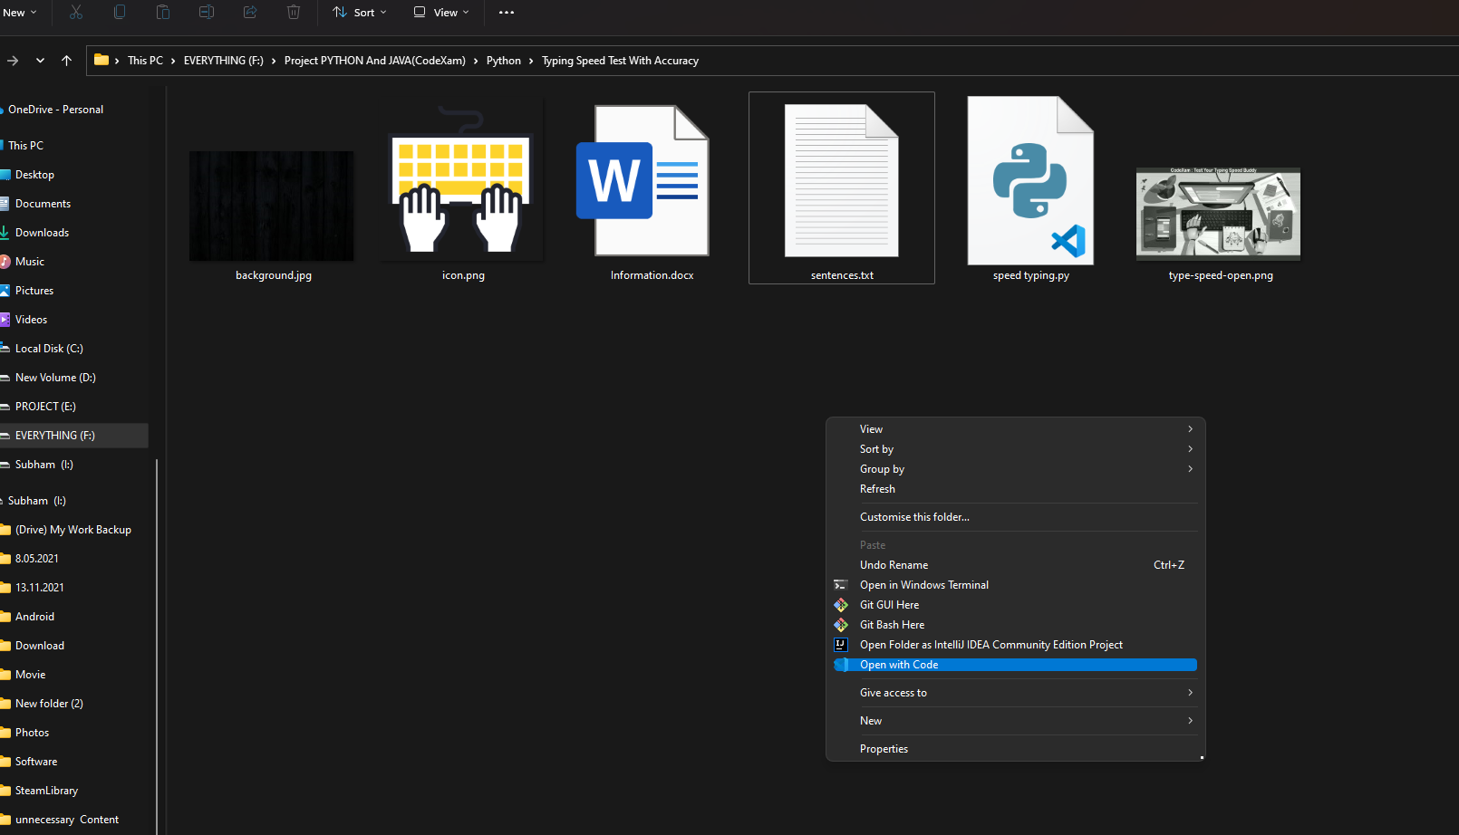

1. In this Python project idea, we are going to build an exciting project through which you can **check** and even **improve** your typing speed. For a graphical user interface, we are going to use the **pygame** library which is used for working with graphics. We will draw the images and text to be displayed on the screen.
2. The project in Python requires you to have basic knowledge of python programming and the pygame library. To install the pygame library, type the following code in your terminal.

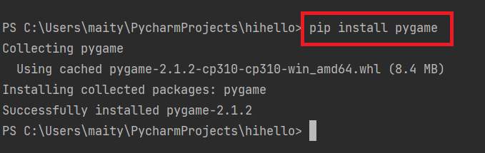

Let us understand the file structure of the Python project with the source code that we are going to build:

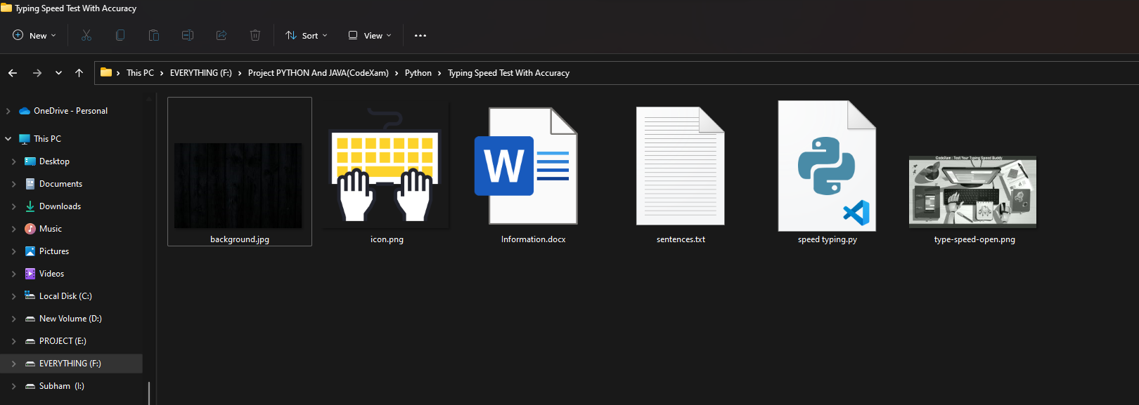

* **Background.jpg –** A background image we will use in our program
* **Icon.png –** An icon image that we will use as a reset button.
* **Sentences.txt –** This text file will contain a list of sentences separated by a new line.
* **Speed typing.py –** The main program file that contains all the code
* **Typing-speed-open.png –** The image to display when starting the game

**First, we have created the sentences.txt file in which we have added multiple sentences separated by a new line.**

**This time we will be using an Object-oriented approach to build the program.**

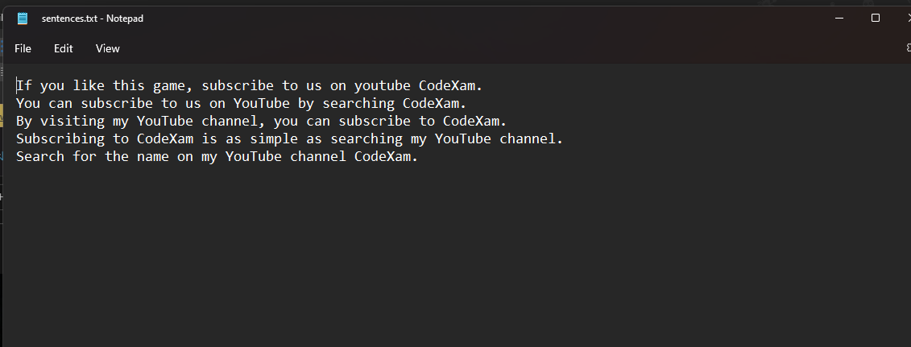

1. Import the libraries

For this project based on Python, we are using the pygame library. So we need to import the library along with some built-in modules of Python like time and random library.

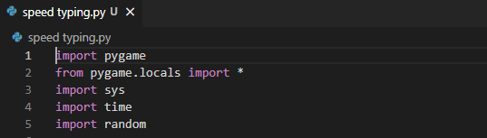

import pygame

from pygame.locals import *

import sys

import time

import random

### 2. Create the game class

Now we create the game class which will involve many functions responsible for starting the game, reset the game and few helper functions to perform calculations that are required for our project in Python.

Let’s go ahead and create the constructor for our class where we define all the variables we will use in our project.

class Game:

    def __init__(self):

        self.w=750

        self.h=500

        self.reset=True

        self.active = False

        self.input_text=''

        self.word = ''

        self.time_start = 0

        self.total_time = 0

        self.accuracy = '0%'

        self.results = 'Time:0 Accuracy:0 % Wpm:0 '

        self.wpm = 0

        self.end = False

        self.HEAD_C = (255,213,102)

        self.TEXT_C = (240,240,240)

        self.RESULT_C = (255,70,70)

        pygame.init()

        self.open_img = pygame.image.load('type-speed-open.png')

        self.open_img = pygame.transform.scale(self.open_img, (self.w,self.h))

        self.bg = pygame.image.load('background.jpg')

        self.bg = pygame.transform.scale(self.bg, (500,750))

        self.screen = pygame.display.set_mode((self.w,self.h))

        pygame.display.set_caption('Type Speed test')

In this constructor, we have initialized the width and height of the window, variables that are needed for calculation and then we initialized the pygame and loaded the images. The screen variable is the most important on which we will draw everything.

### 3. draw_text() method

The draw_text() method of Game class is a **helper function** that will draw the text on the screen. The argument it takes is the screen, the message we want to draw, the coordinate of the screen to position our text, the size of the font, and the color of the font. We will draw everything in the center of the screen. After drawing anything on the screen, pygame requires you to update the screen.

def draw_text(self, screen, msg, y ,fsize, color):

    font = pygame.font.Font(None, fsize)

    text = font.render(msg, 1,color)

    text_rect = text.get_rect(center=(self.w/2, y))

    screen.blit(text, text_rect)

    pygame.display.update()

### 4. get_sentence() method

Remember that we have a list of sentences in our sentences.txt file? The get_sentence() method will open up the file and **return a random sentence** from the list. We split the whole [string](https://developers.google.com/edu/python/strings) with a newline character.

def get_sentence(self):

    f = open('sentences.txt').read()

    sentences = f.split('\n')

    sentence = random.choice(sentences)

    return sentence

### 5. show_results() method

The show_results() method is where we **calculate the speed** of the user’s typing. The time starts when the user clicks on the input box and when the user hits the return key “Enter” then we perform the difference and calculate time in seconds.

To calculate accuracy, we did a little bit of math. We counted the correct typed characters by comparing input text with the display text which the user had to type.

The formula for accuracy is:

**(correct characters)x100/ (total characters in sentence)**

The WPM is the words per minute. A typical word consists of around 5 characters, so we calculate the words per minute by dividing the total number of words by five, and then the result is again divided with the total time it took in minutes. Since our total time was in seconds, we had to convert it into minutes by dividing the total time by 60.

At last, we have drawn the typing icon image at the bottom of the screen which we will use as a reset button. When the user clicks it, our game would reset. We will see the reset_game() method later in this article.

def show_results(self, screen):

    if(not self.end):

        #Calculate time

        self.total_time = time.time() - self.time_start

        #Calculate accuracy

        count = 0

        for i,c in enumerate(self.word):

            try:

                if self.input_text[i] == c:

                    count += 1

            except:

                pass

        self.accuracy = count/len(self.word)*100

        #Calculate words per minute

        self.wpm = len(self.input_text)*60/(5*self.total_time)

        self.end = True

        print(self.total_time)

        self.results = 'Time:'+str(round(self.total_time)) +" secs Accuracy:"+ str(round(self.accuracy)) + "%" + ' Wpm: ' + str(round(self.wpm))

        # draw icon image

        self.time_img = pygame.image.load('icon.png')

        self.time_img = pygame.transform.scale(self.time_img, (150,150))

        #screen.blit(self.time_img, (80,320))

        screen.blit(self.time_img, (self.w/2-75,self.h-140))

        self.draw_text(screen,"Reset", self.h - 70, 26, (100,100,100))

        print(self.results)

        pygame.display.update()

### 6. run() method

This is the main method of our class that will**handle all the events**. We call the reset_game() method at the starting of this method which resets all the variables. Next, we run an infinite loop that will capture all the mouse and keyboard events. Then, we draw the heading and the input box on the screen.

We then use another [loop](https://docs.python.org/3/tutorial/controlflow.html) that will look for the mouse and keyboard events. When the mouse button is pressed, we check the position of the mouse if it is on the input box then we start the time and set the active to True. If it is on the reset button, then we reset the game.

When the active is True and typing has not ended then we look for keyboard events. If the user presses any key then we need to update the message on our input box. The enter key will end typing and we will calculate the scores to display it. Another event of a backspace is used to trim the input text by removing the last character.

def run(self):

    self.reset_game()

    self.running=True

    while(self.running):

        clock = pygame.time.Clock()

        self.screen.fill((0,0,0), (50,250,650,50))

        pygame.draw.rect(self.screen,self.HEAD_C, (50,250,650,50), 2)

        # update the text of user input

        self.draw_text(self.screen, self.input_text, 274, 26,(250,250,250))

        pygame.display.update()

        for event in pygame.event.get():

            if event.type == QUIT:

                self.running = False

                sys.exit()

            elif event.type == pygame.MOUSEBUTTONUP:

                x,y = pygame.mouse.get_pos()

                # position of input box

                if(x>=50 and x<=650 and y>=250 and y<=300):

                    self.active = True

                    self.input_text = ''

                    self.time_start = time.time()

                 # position of reset box

                 if(x>=310 and x<=510 and y>=390 and self.end):

                    self.reset_game()

                    x,y = pygame.mouse.get_pos()

            elif event.type == pygame.KEYDOWN:

                if self.active and not self.end:

                    if event.key == pygame.K_RETURN:

                        print(self.input_text)

                        self.show_results(self.screen)

                        print(self.results)

                        self.draw_text(self.screen, self.results,350, 28, self.RESULT_C)

                        self.end = True

                    elif event.key == pygame.K_BACKSPACE:

                        self.input_text = self.input_text[:-1]

                    else:

                        try:

                            self.input_text += event.unicode

                        except:

                            pass

        pygame.display.update()

    clock.tick(60)

### 7. reset_game() method

The reset_game() method **resets all variables** so that we can start testing our typing speed again. We also select a random sentence by calling the get_sentence() method. In the end, we have closed the class definition and created the object of Game class to run the program.

    def reset_game(self):

        self.screen.blit(self.open_img, (0,0))

        pygame.display.update()

        time.sleep(1)

        self.reset=False

        self.end = False

        self.input_text=''

        self.word = ''

        self.time_start = 0

        self.total_time = 0

        self.wpm = 0

        # Get random sentence

        self.word = self.get_sentence()

        if (not self.word): self.reset_game()

        #drawing heading

        self.screen.fill((0,0,0))

        self.screen.blit(self.bg,(0,0))

        msg = "Typing Speed Test"

        self.draw_text(self.screen, msg,80, 80,self.HEAD_C)

        # draw the rectangle for input box

        pygame.draw.rect(self.screen,(255,192,25), (50,250,650,50), 2)

        # draw the sentence string

        self.draw_text(self.screen, self.word,200, 28,self.TEXT_C)

        pygame.display.update()

Game().run()

Entire Code :

import pygame

from pygame.locals import *

import sys

import time

import random

# 750 x 500

class Game:

    def __init__(self):

        self.w=750

        self.h=500

        self.reset=True

        self.active = False

        self.input_text=''

        self.word = ''

        self.time_start = 0

        self.total_time = 0

        self.accuracy = '0%'

        self.results = 'Time:0 Accuracy:0 % Wpm:0 '

        self.wpm = 0

        self.end = False

        self.HEAD_C = (255,213,102)

        self.TEXT_C = (240,240,240)

        self.RESULT_C = (255,70,70)

        pygame.init()

        self.open_img = pygame.image.load('type-speed-open.png')

        self.open_img = pygame.transform.scale(self.open_img, (self.w,self.h))

        self.bg = pygame.image.load('background.jpg')

        self.bg = pygame.transform.scale(self.bg, (500,750))

        self.screen = pygame.display.set_mode((self.w,self.h))

        pygame.display.set_caption('Type Speed test')

    def draw_text(self, screen, msg, y ,fsize, color):

        font = pygame.font.Font(None, fsize)

        text = font.render(msg, 1,color)

        text_rect = text.get_rect(center=(self.w/2, y))

        screen.blit(text, text_rect)

        pygame.display.update()

    def get_sentence(self):

        f = open('sentences.txt').read()

        sentences = f.split('\n')

        sentence = random.choice(sentences)

        return sentence

    def show_results(self, screen):

        if(not self.end):

            #Calculate time

            self.total_time = time.time() - self.time_start

            #Calculate accuracy

            count = 0

            for i,c in enumerate(self.word):

                try:

                    if self.input_text[i] == c:

                        count += 1

                except:

                    pass

            self.accuracy = count/len(self.word)*100

            #Calculate words per minute

            self.wpm = len(self.input_text)*60/(5*self.total_time)

            self.end = True

            print(self.total_time)

            self.results = 'Time:'+str(round(self.total_time)) +" secs   Accuracy:"+ str(round(self.accuracy)) + "%" + '   Wpm: ' + str(round(self.wpm))

            # draw icon image

            self.time_img = pygame.image.load('icon.png')

            self.time_img = pygame.transform.scale(self.time_img, (150,150))

            #screen.blit(self.time_img, (80,320))

            screen.blit(self.time_img, (self.w/2-75,self.h-140))

            self.draw_text(screen,"Reset", self.h - 70, 26, (100,100,100))

            print(self.results)

            pygame.display.update()

    def run(self):

        self.reset_game()

        self.running=True

        while(self.running):

            clock = pygame.time.Clock()

            self.screen.fill((0,0,0), (50,250,650,50))

            pygame.draw.rect(self.screen,self.HEAD_C, (50,250,650,50), 2)

            # update the text of user input

            self.draw_text(self.screen, self.input_text, 274, 26,(250,250,250))

            pygame.display.update()

            for event in pygame.event.get():

                if event.type == QUIT:

                    self.running = False

                    sys.exit()

                elif event.type == pygame.MOUSEBUTTONUP:

                    x,y = pygame.mouse.get_pos()

                    # position of input box

                    if(x>=50 and x<=650 and y>=250 and y<=300):

                        self.active = True

                        self.input_text = ''

                        self.time_start = time.time()

                     # position of reset box

                    if(x>=310 and x<=510 and y>=390 and self.end):

                        self.reset_game()

                        x,y = pygame.mouse.get_pos()

                elif event.type == pygame.KEYDOWN:

                    if self.active and not self.end:

                        if event.key == pygame.K_RETURN:

                            print(self.input_text)

                            self.show_results(self.screen)

                            print(self.results)

                            self.draw_text(self.screen, self.results,350, 28, self.RESULT_C)

                            self.end = True

                        elif event.key == pygame.K_BACKSPACE:

                            self.input_text = self.input_text[:-1]

                        else:

                            try:

                                self.input_text += event.unicode

                            except:

                                pass

            pygame.display.update()

        clock.tick(60)

    def reset_game(self):

        self.screen.blit(self.open_img, (0,0))

        pygame.display.update()

        time.sleep(1)

        self.reset=False

        self.end = False

        self.input_text=''

        self.word = ''

        self.time_start = 0

        self.total_time = 0

        self.wpm = 0

        # Get random sentence

        self.word = self.get_sentence()

        if (not self.word): self.reset_game()

        #drawing heading

        self.screen.fill((0,0,0))

        self.screen.blit(self.bg,(0,0))

        msg = "Typing Speed Test"

        self.draw_text(self.screen, msg,80, 80,self.HEAD_C)

        # draw the rectangle for input box

        pygame.draw.rect(self.screen,(255,192,25), (50,250,650,50), 2)

        # draw the sentence string

        self.draw_text(self.screen, self.word,200, 28,self.TEXT_C)

        pygame.display.update()

Game().run()

Output :

